SE 630
Homework Assignment 7

Name: Yiyun Zhang
Date: May 27, 2020

Due Date: See syllabus

1. [25 Points]
Answer Self-study Questions #7 and #8 in Chapter 19.

#7

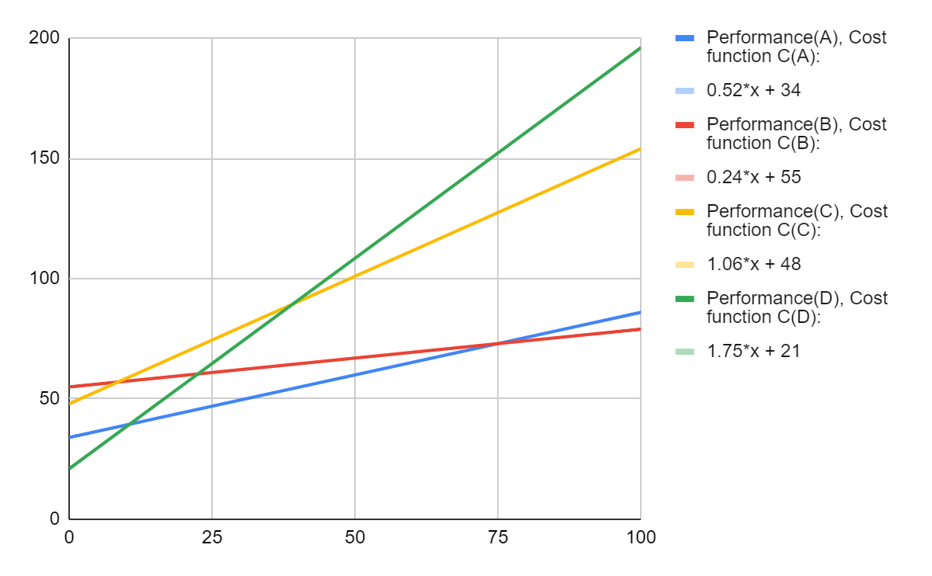
X axis is entry number, Y axis is the performance time

Pair | Decision Variable at Break-Even Point | Cost Function at Break-Even Point
C(A):C(B) | 75 | 73
C(A):C(C) | -26 | N/A
C(A):C(D) | 11 | 40
C(B):C(C) | 9 | 57
C(B):C(D) | 23 | 61
C(C):C(D) | 39 | 89

#8

Cost function at Break-Even Point C(A):C(B):

Cost Function | Cost at This Break-Even Point
C(A) | 73
C(B) | 73
C(C) | 128
C(D) | 152

Cost function at Break-Even Point C(C):C(D) :

Cost Function | Cost at This Break-Even Point
C(A) | 54
C(B) | 64
C(C) | 89
C(D) | 89

Cost function at Break-Even Point C(A):C(C) :

Cost Function | Cost at This Break-Even Point
C(A) | 40
C(B) | 58
C(C) | 60
C(D) | 40

Cost function at Break-Even Point C(B):C(C) :

Cost Function | Cost at This Break-Even Point
C(A) | 39
C(B) | 57
C(C) | 57
C(D) | 37

Cost function at Break-Even Point C(B):C(D) :

Cost Function | Cost at This Break-Even Point
C(A) | 46
C(B) | 61
C(C) | 72
C(D) | 61

At C(A):C(B) break-even point, cost functions C(A) and C(B) have the lowest cost.
At C(A):C(D) break-even point, cost functions C(A) and C(D) have the lowest cost.

Cost Function | Decision Variable at Break-Even Point | Cost Function at Break-Even Point
C(A):C(D) | 11 | 40
C(A):C(B) | 75 | 73

Routine A is the best when the list size is between 11 to 75 entries.
Routine B is the best for list sizes over 75 entries.
Routine C is not the best for all entries range.
Routine D is the best for list sizes up to 11 entries.

2. [10 Points]
Answer Self-study Question #10 in Chapter 19.

Let number of units be x
The Cost Function for UART: 5 * $85 + $0.25 * x = $0.25 * x + $425
The Cost Function for software solution: 20 * $85 = $1,700
Let $0.25 * x + $425 = $1,700
x = 5,100
Therefore, the break-even point between the two proposed solutions:
Pair | Decision Variable at Break-Even Point | Cost Function at Break-Even Point
C(A):C(B) | 5100 | 1700

